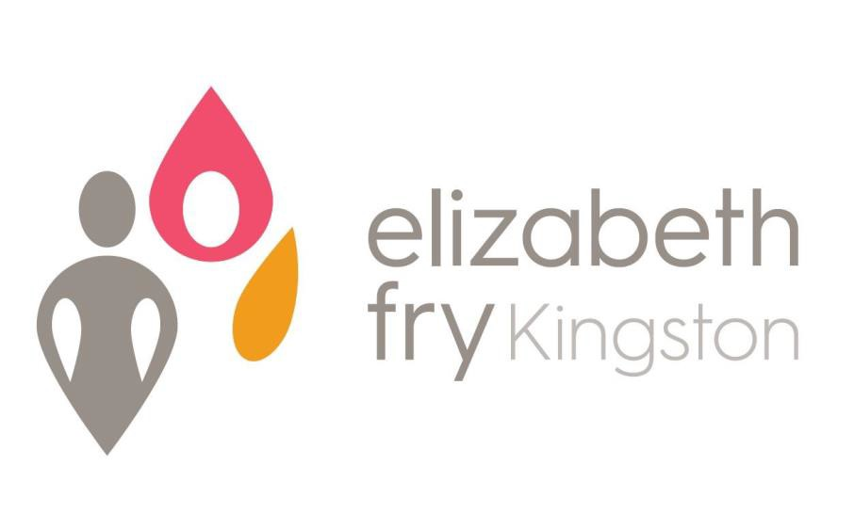
Annual Report 2019-2020

Elizabeth Fry Kingston is a non-profit organization that serves women in conflict with the law and women at risk due to financial and social barriers;
We advocate for progressive legislative and administrative reform of the Criminal Justice System and other institutions;
We educate about issues that disadvantage women in the justice system;
We encourage public participation in all aspects of justice for women

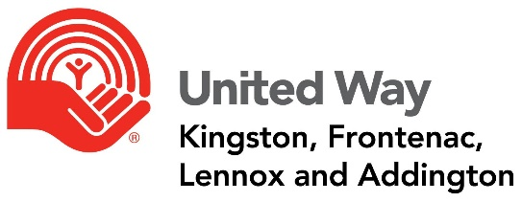

President’s Message 2020

It is my great pleasure to report as President of the Board of Directors to our Board Members, staff, volunteers, retirees, and the women we serve.
This has been a most trying year for all. Our need to address the pandemic safely has curtailed much of the programming and services the Society of Kingston has to offer.
During this year, through diligence, focus, and hard work, our agency has maintained a safe and healthy environment for the women and staff of Detweiler House. Within the parameters allowed, programs have continued in the HUB to the maximum of attendees permitted. This is most commendable to our Executive Director and the staff and volunteers.
The three major projects coordinated by Board, staff, and outside support such as Queen’s Smith School of Business MBA students, Spark Creative, and the United Way of Kingston are coming to finality even with the delays caused by the pandemic restrictions- our new website is now live; the placement and erection of the Tipi is imminent, and the Five Year Strategic Plan can be finished and finalized with the direction of the new, expanded Board of Directors.
These accomplishments and successes are a testament to our belief in the Society and the goal of justice, equality, and respect for all women.
As outgoing President, I wish to express my deepest gratitude to everyone for providing support and understanding with each other always. A special thank you to our Executive Director, Kathryn Londry, for her guidance and patience, and to the entire staff for their unwavering dedication to the work we do.
I look forward to continuing as a Board member of the Society in Kingston and contributing to the success of your new Board, its Executive, and staff.

Sincerely,

James McCartney

Executive Director’s Report 2020

This year marks 71 years that Elizabeth Fry Kingston has had a presence in the Kingston community and has provided support and services to women within our many programs. Without a doubt, it has been the most challenging year yet with the Coronavirus outbreak and resulting lockdown in mid-March. Unfortunately, we were forced to close two of our pillar programs during this time in order to adhere to government guidelines regarding social distancing, and in an effort to decrease the risk of spreading the virus. The Women Empowered (WE) Hub and the C.A.R.E. (Court Accompaniment, Referral and Education) Program became non-operational in March. However, as can be expected, women’s needs, risk factors, challenges and mental health have remained, even enhanced, during this period and the pandemic has not alleviated their reliance on us. While the Hub space and the courts remain closed, our incredible staff reached out and maintained regular communication with the women by telephone and have since adapted programming in order to maintain some measure of stability. We have developed a roster of smaller groups for the women, all facilitated by our current staff, in order to limit the number of people from the community in the space. This has benefitted the women in a multitude of ways including reduced isolation and loneliness, improved community connection, customized programming and service referrals, gender specific safe space, and mental and emotional support.

The Community Residential Facility and Kaye Healey Homes/Russell Street Housing programs have maintained operations with adaptations. The CRF staff have been steadfast in their dedication and commitment to the women who reside at Detweiler House. They immediately developed and implemented COVID-19 protocols, even as the information we were receiving on the virus seemed to change on a daily basis. They were successful in protecting and maintaining the safety of both residents and staff.

While these past few months have been unprecedented, our volunteers, staff, and Board of Directors are a caring and passionate team, committed to improving the lives of women and providing effective, high-quality services to those who need it most.

Stay safe,
Kathryn Londry

BOARD & STAFF OF ELIZABETH FRY KINGSTON
November 2020

President Jim McCartney
Vice-President Yvonne Holland
Treasurer Cathy Tyrrell
Secretary Mary Lou McCartney
Members of the Board Fran Chaisson
Haley Cochrane
Geoff Coons
Esther Deck
Barbara Hough
Dawn Quelch

Executive Director | Kathryn Londry
Mental Health Support Worker | Tabatha Maloney
Financial Administrator | Julie Spencer
Office Administrator | Deb Campbell
Community Outreach Worker | Michelle McCaugherty
Community Outreach Worker/  Programs Co-ordinator-WE Hub | Rebecca McLauchlan
Grants Co-ordinator | Stacey Alarie
Residential Case Managers | Paola Gongora  Alyssa Henry  Alicia Howell (currently on maternity leave)  Samantha Orr
Residential Night/Weekend Staff | Amberlee Burns  Joy Harrison  Helen Wood
W.E.L.L. Program Facilitator | Judi Burrill  Allison Thompson

ORGANIZATIONAL CHART
Board Committees & Representation

Executive
Finance
Personnel
Policies, Procedures, and Governance
Admissions
Bursary

Membership
Board of Directors
Executive Director is Ex Officio Board Member
Executive Committee

Executive Director

C.A.R.E.
Program
Project Lead
Program Co-ordinator
WE Hub
(0.5)
Mental Health Support Worker
CRF
Case Managers
(3)
Programming Services

- Kaye Healey Homes & Supportive Non-Profit Housing Program
- Homelessness Prevention
- Women Empowered (WE) Hub
- Community Outreach & Education
- C.A.R.E. (Court Accompaniment, Referral & Education) Program
- Reintegration Support
- Residential Program (CRF)
- Institutional Visitation
- Mental Health Support
- Community Kitchen / Garden
Community Outreach Worker
(1.5)
Relief Residential Staff
Students
Volunteers
Office Administrator
Financial
Administrator

ELIZABETH FRY KINGSTON
Statement of Revenue and Expenses
For Year Ending March 31, 2020
Revenue | 2019/2020
City of Kingston | $ 444,722
Residential Contracts | $ 233,754
Other Contracts | $ 102,711
Rental Income | $ 190,960
United Way KFLA | $ 67,812
Detweiler Estate | $ 37,035
OLG Revenue | $ 27,962
Donations and Fundraising | $ 25,661
Grants | $ 91,200
Other
Total | $ 1,221,817
Expenses | 2019/2020
Salaries & Benefits | $ 606,604
Mortgage Interest & Taxes | $ 114,186
Utilities | $ 95,778
Repairs & Maintenance | $ 106,405
Office & Telecommunications | $ 44,773
Client & Program Expenses | $ 21,881
Rental Expense | $ 12,198
Training & Meeting Expense | $ 5,159
Professional Fees | $ 41,226
Travel | $ 24,456
Reserve Fund Expenditures | $ 5,628
Insurance | $ 19,215
Hub Renovations | $ 1,019
Bad Debts | $ 228
Total | $ 1,098,756
Excess Revenue over Expenses | $ 123,061
Forgivable Loan Interest | $ - 8,613
Loan Interest Forgiveness | $ 8,613
Amortization of Deferred Contributions | $ 8,518
Amortization of Capital Assets | $ - 139,013
Subsidy Adjustment for Prior Year | $
Balance | $ - 7,434
STATEMENT OF REVENUE AND EXPENSES

♀SPECIAL THANKS & ACKNOWLEDGEMENTS♀
Funders and Supporters of Elizabeth Fry

FUNDERS
City of Kingston – Community & Family Services
Correctional Service Canada
Ministry of Community Safety & Correctional Services
United Way of KFL&A
The Law Foundation of Ontario
Detweiler Estate
Human Resources Development Canada (HRDC)
Community Spirit Bingo
Community Foundation of Kingston & Area

SUPPORTERS
Women’s Interfaith Group
Canadian Association of Elizabeth Fry Societies
Kingston Peer Support
P4W Memorial Collective
Partners in Mission Food Bank
Loving Hands
Home Depot
The Elm Cafe
Queen’s University Pro Bono Law Students
ReStart
Rustle Church
St. Lawrence College
The Elm Cafe
Value Village

127 Charles Street
Kingston, ON
K7K 1V8

Telephone: 613-544-1744
Toll Free Line: 1-888-560-3379
Fax: 613-544-0676
Email: info@efrykingston.ca

www.efrykingston.ca

JOIN US!!

www.twitter.com/efrykingston www.facebook.com/efrykingston

The views contained in this document do not necessarily reflect those of the Federal or Ontario Governments or our funder

