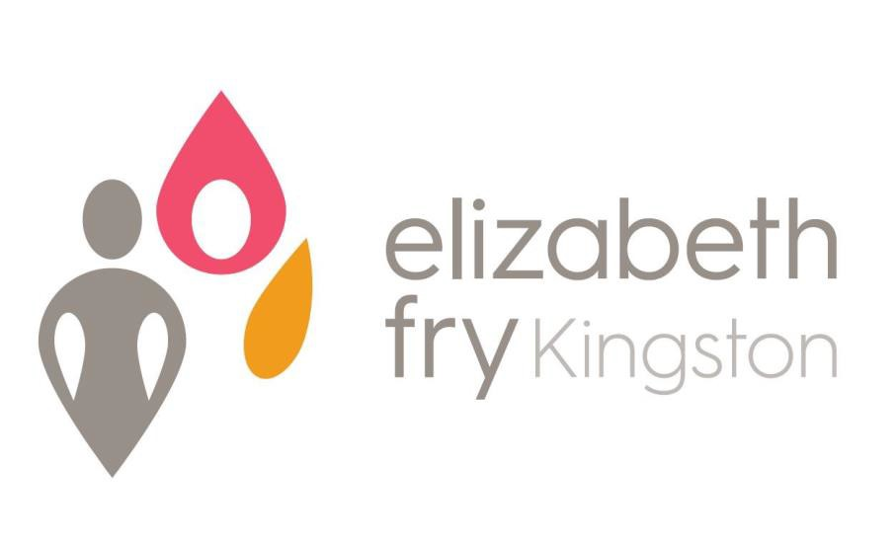
Annual Report 2020-2021

Elizabeth Fry Kingston is a non-profit organization that serves women in conflict with the law and women at risk due to financial and social barriers;
We advocate for progressive legislative and administrative reform of the Criminal Justice System and other institutions;
We educate about issues that disadvantage women in the justice system;
We encourage public participation in all aspects of justice for women
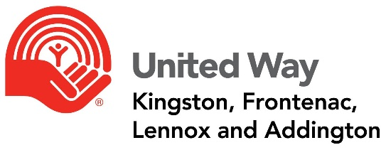

President’s Report 2020-2021
It is with great pride and pleasure to report as President of the Board of Directors to our Board members, staff, volunteers, retirees and to all the women we serve here at Elizabeth Fry Kingston.
This has been another year of consequences from the COVID-19 closures, slow-downs and shut downs, fluid and changing workplace re-entry protocols together with shifting distancing/vaccine and healthcare management mandates from all levels of Government. Notwithstanding the added layers of administration required of our agency, we have maintained a safe and healthy home and work environment, and more importantly, we have kept everyone safe. An enormous thank you to our Executive Director Kathryn Londry, her team and to all of our staff and volunteers…we really were and continue to all be in this together! The challenges we experienced as a result of the mandatory Covid -19 requirements were mitigated through teamwork, communication, steadfast leadership and women passionate about serving our clients.
Despite the impact the COVID restrictions imposed on our agency we undertook a long overdue roof replacement of 127 Charles Street including the downspouts, drains and flashing. The general contractor who completed the work did so in record time, on budget and with little to no interruption to the continued operation of the agency.
For the first time in recent memory E Fry Kingston now has a full complement of directors on its Board. I am also delighted to report that all meetings since November of 2020 have been hosted electronically by Geoff Coons (Queen's University) and quorum has been achieved for all meetings. With the recent reduction in the distancing requirements, some board members have been able to attend the last few meetings in person at the agency.
Our relationship with Queens University continues to grow in involvedness and depth. Experiential learning opportunities this past year were created through E Fry which have been supported by students from the Queens MBA, MIB, Department of Psychiatry, Faculty of Law, Nursing and Social Impact programs. This precious relationship helps to provide hands on learning opportunities for students, and invaluable support for E Fry programming and the women we serve.
Although not permitted access to incarcerated women due to Covid restrictions, work continues to support them as soon as the restrictions are removed. Weekly outreach during Covid, by way of telephone, helped to ameliorate loneliness, anxiousness and isolation for women missing the programming we offer through the WE Hub.
I look forward to working with all of you over the next 12 months in support of our new Women Re-integrating After Prison program (W.R.A.P.), operationalizing the new Tipi, reactivating and growing the WE Hub programs and, as soon as we are able, continuing to support, in person, our incarcerated women in the institutions.
Thank you
Yvonne Holland

Executive Director’s Report 2021/22
This was a year with many changes and uncertainties, but also one which included growth and successes within the agency. The Community Residential Facility and Kaye Healey Homes/Russell Street housing programs maintained operations throughout the pandemic, and the staff showed incredible dedication and commitment while we navigated the various stages of lockdown.
In the past year, in spite of all the obstacles and challenges presented during the Covid-19 pandemic, we have managed to continue to provide programming in the WE (Women Empowered) Hub. Although we have had fewer participants in the space due to government-mandated guidelines for public health and safety, and we’ve had to modify the means by which we interact, we have seen an uptake in the number of women wishing to access the services in the Hub. We have been creative in respect to these requests by, for example, doing a lot over the phone and bringing the WE Hub to women directly in some capacity. One of the ways we were able to do that was with the fabulous support of our community partner, the Kingston Women’s Inter-Faith Group. Rather than attending the Community Kitchen in person as they did pre-pandemic, members of the Group brought food to our office once a month, where we were able to package up individual meals and deliver them to the women in the community.
In 2012, the Officer of the Correctional Investigator assessed the issues facing Canada’s Indigenous Peoples in the federal correctional system to be both significant and urgent. In response to that, and to increase the capacity of Aboriginal specific community resources for Indigenous women, E. Fry sought and were honoured to secure funds specifically to facilitate the development of Indigenous Traditional Grounds on the property of our Community Residential Facility. The Ceremonial Groups and Tipi will provide a new culturally relevant resource to the Indigenous clients of E. Fry. As the Opening Ceremony was just held on September 30th of this year, we are currently working on a protocol document which will include consultation with the clients and community to identify the uses, care and protocols to follow when using the Tipi and holding ceremonies. The Tipi is a stunning addition to our property and we are so very grateful to be able to provide this spiritual, healing space for the women with whom we work and the community at large.
This year saw the creation of a new program in the agency. Based on a report by Sophie Lachapelle, “It’s Set Up So You Trip and Fall”, the WRAP (Women Reintegrating After Prison) Program was developed. Using a client-led program model, this program will provide wrap-around supports for women reintegrating into the Kingston community upon release from federal and/or provincial institutions. As Sophie’s research clearly showed, the process of leaving prison and reintegrating into our community is an overwhelmingly complicated task and it is our goal to make this transition easier by matching women with a trained volunteer who will become that client’s Volunteer Case Manager. Together they will navigate the various systems in the community and focus on ten specific areas: 1) Identification; 2) Housing; 3) Employment; 4) Health Care; 5) Food Security; 6) Transportation; 7) City Orientation; 9) Relationship Building; 9) Advocacy; and 10) Community Involvement. We are very excited about this new program and hope to start training the volunteers in January.
I would like to take this opportunity to sincerely thank the Staff and Board of Elizabeth Fry Kingston who have worked together to ensure the agency continues to provide high quality services to the women we work with in the community. We have a very caring and committed team and I am proud to be a part of it.
Stay safe
Kathryn Londry

BOARD & STAFF OF ELIZABETH FRY KINGSTON
November 2021

President Yvonne Holland
Past President Jim McCartney
Vice-President Geoff Coons
Treasurer Helen Kobusinge
Secretary Haley Cochrane
Members of the Board Fran Chaisson
Esther Deck
Mary Lou McCartney
Meg McQueen
Lillian Murdock
Heather Morrison

Executive Director | Kathryn Londry
Mental Health Support Worker | Judi Burrill (Tabatha Maloney currently on Maternity Leave)
Financial Administrator | Julie Spencer
Office Administrator | Deb Campbell
Community Outreach Worker | Michelle McCaugherty
Community Outreach Worker/  Programs Co-ordinator-WE Hub | Rebecca McLauchlan
Grants Co-ordinator | Stacey Alarie
CRF Manager | Alyssa Henry
Residential Case Managers | Samantha Orr  Meagan Donnelly  Amber Lockwood
Residential Night/Weekend Staff | Joy Harrison  Jezihna Pascoal

ORGANIZATIONAL CHART
Board Committees & Representation

Executive
Finance
Personnel
Policies, Procedures, and Governance
Admissions
Bursary

Membership
Board of Directors
Executive Director is Ex Officio Board Member
Executive Committee

Executive Director

CRF Manager
C.A.R.E.
Program
Project Lead
Program Co-ordinator
WE Hub
(0.5)
Mental Health Support Worker
CRF
Case Managers
(2 FTE)
Community Outreach Worker
(1.5)
Relief Residential Staff
Students
Volunteers
Office Administrator
Financial
Administrator

Programming Services

- Kaye Healey Homes & Supportive Non-Profit Housing Program
- Homelessness Prevention
- Women Empowered (WE) Hub
- Community Outreach & Education
- C.A.R.E. (Court Accompaniment, Referral & Education) Program
- Reintegration Support
- Residential Program (CRF)
- Institutional Visitation
- Mental Health Support
- Community Kitchen / Garden
- WRAP (Women Re-integrating
After Prison) Program

ELIZABETH FRY KINGSTON
Statement of Revenue and Expenses
For Year Ending March 31, 2021
Revenue | 2020/2021
City of Kingston | $ 424,406
Residential Contracts | $ 258,494
Other Contracts | $
Rental Income | $ 204,920
Detweiler Estate | $ 50,400
OLG Revenue | $ 13,700
Donations and Fundraising | $ 11,957
Grants | $ 99,792
Other | $ 10,405
Total | $ 1,074,074
Expenses | 2019/2020
Salaries & Benefits | $ 478,734
Mortgage Interest & Taxes | $ 112,279
Bank Charges | $ 2,228
Utilities | $ 96,437
Repairs & Maintenance | $ 108,964
Office & Telecommunications | $ 41,415
Client & Program Expenses | $ 12,666
Rental Expense | $ 12,730
Training & Meeting Expense | $ 2,250
Professional Fees | $ 37,593
Travel | $ 10,571
Reserve Fund Expenditures | $ 23,387
Insurance | $ 21,873
Bad Debts | $ 9,670
Total | $ 970,797
Excess Revenue over Expenses | $ 103,277
Forgivable Loan Interest | $ - 7,743
Loan Interest Forgiveness | $ 7,743
Amortization of Deferred Contributions | $ 8,518
Amortization of Capital Assets | $ - 144,238
Excess Revenue over Expenses Before Covid Relief Fund | $ - 32,443
Covid Relief | $ 153,869
Canadian Association of Elizabeth Fry Societies | $ 23,000
 | $
Expenditures Over Revenue for the Year | $ 144,426
STATEMENT OF REVENUE AND EXPENSES

♀SPECIAL THANKS & ACKNOWLEDGEMENTS♀
Funders and Supporters of Elizabeth Fry

FUNDERS
City of Kingston – Community & Family Services
Correctional Service Canada
Ministry of Community Safety & Correctional Services
United Way of KFL&A
Women and Gender Equality
Detweiler Estate
Human Resources Development Canada (HRDC)
Community Spirit Bingo
Community Foundation of Kingston & Area
Ministry of Children, Community & Social Services

SUPPORTERS
Canadian Association of Elizabeth Fry Societies
Cupido Construction
Daughters General Store
Home Depot
Impact Church
Kingston Women’s Inter-Faith Group
Loving Hands
Malette Electric
P4W Memorial Collective
Partners in Mission Food Bank
Peer Support South East Ontario
Queen’s University
Second Harvest
St. Lawrence College
Suzanne Fast Design
The Elm Cafe

127 Charles Street
Kingston, ON
K7K 1V8

Telephone: 613-544-1744
Toll Free Line: 1-888-560-3379
Fax: 613-544-0676
Email: info@efrykingston.ca

www.efrykingston.ca

JOIN US!!

www.twitter.com/efrykingston www.facebook.com/efrykingston

The views contained in this document do not necessarily reflect those of the Federal or Ontario Governments or our funders

