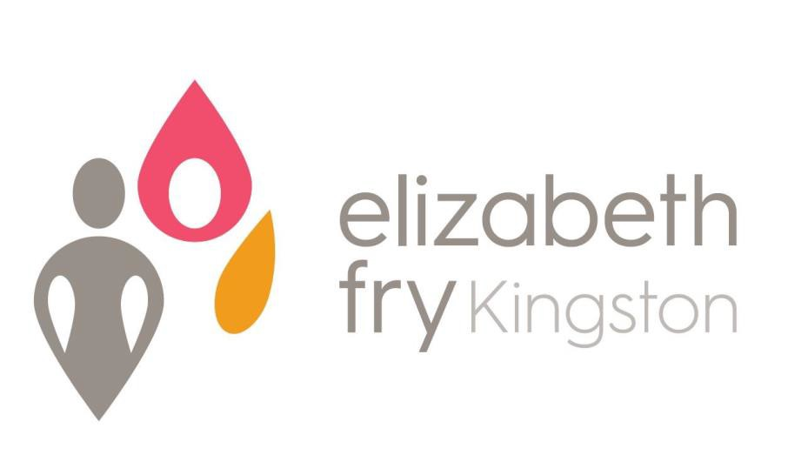
Annual Report 2022

A world of dignity and equality for all women.
Mission Statement
Empowering women through provision of community outreach, social
justice services, and affordable housing

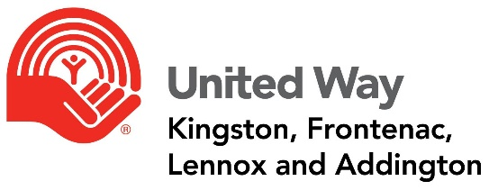
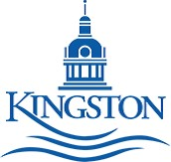

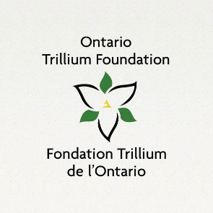

President’s Report 2022

It is indeed with great pride that I provide the following President’s Message as the Board Chairperson for Elizabeth Fry Kingston.

What follows will also be my last annual report as your Board President as my term comes to an end. Effective February 2023 I will be stepping aside to assume the position of Past President, enabling a newly elected President to take the helm. It has been a privilege to be your President for the last two years.

I am pleased to affirm that, through the benefit of modern technology (Zoom) provided by our Vice President, Geoff Coons, we were successful in achieving quorum for all of our 2022 board meetings.

To say that 2022 was a turbulent year would be an understatement. Despite continued mandatory COVID 19 restrictions and protocols, staff absences, human resource churn, Deborah Campbell’s retirement, operational and tenant issues within our property portfolio, combined with the overall mental health stress at our agency, the city, province, nationally and indeed globally … 2022 was trying. A personal thank you to our Executive Director, Kathryn Londry - her steady hand on the tiller kept us afloat and moving us forward despite choppy water!

The unique and special relationship between Elizabeth Fry Kingston and Queen’s University continues to deepen, providing dividends for both the agency and Queen’s students. Experiential learning opportunities were created at the agency, providing students from the Queen’s Smith School of Business, Department of Psychiatry, the Faculty of Nursing, Law, and the Queen’s Feminist Collective with exceptional, and ongoing learning opportunities.

Elizabeth Fry Society successfully applied for City of Kingston Housing funding in support of the city’s ‘scattered housing’ program. Our agency received confirmation (December 2022) from the City of Kingston that $165K will be held for our agency for 90 days, until a decision is taken by our board regarding a potential moving forward plan.

Our magnificent tepee has been a significant agency/community success. Much desired Indigenous ceremonies, both small and large, are now able be held on our grounds, with more planned for 2023.

The United Way Board and the Equity Diversity Inclusion and Indigenization Roundtable (EDII) recommended developing resources and road maps for partner agencies, including Elizabeth Fry Kingston, in support of expanding EDII community agency work. Over the last year I have attended several interagency meetings and, as a result, a ‘community of practice’ group has been formed, so we can all learn from each other. EDII work within our agency continues.

Despite the challenges in 2022, the WE Hub continues to thrive. The variety and number of programs expanded over the year, and of course the community kitchen achievements are, and continue to be, far reaching.

Thank you all for your continued support of our outstanding agency, our phenomenal women, our diverse board members, our tireless volunteers, our community partners and, of course, our diligent and astounding staff.

I have learned so much from my role as President over these last two years, and I look forward to serving our agency in 2023.

Sincerely
Yvonne Holland

Executive Director’s Report 2022

I echo our President’s sentiment that 2022 was a very demanding year for many reasons. The Omicron variant forced us to close programs for the month of January and return in February with capacity limits. For two months we delivered “in-house” programming thereby restricting the number of community members in our facilities in an effort to reduce the risk of spreading the virus. This had a significant impact on the women who access the WE Hub as we had only just opened back up after a long closure. We live in a new world, complete with challenges never before experienced and obstacles that have exasperated the risks and needs for women. The staff were diligent in providing welfare checks and mental health calls throughout this period.
This year we were successful in our application for funding from the Ontario Trillium Foundation, which enabled us to develop our technological capacities as an organization. As a component of the W.R.A.P. (Women Reintegrating After Prison) Program, we renovated a vacant office into a 3-person computer lab for our clients. Many of our clients don’t have easy access to technology and/or internet to perform necessary job/housing searches or participate in mandated parole/probation programming. Thanks to the OTF, we are now able to offer that to the women.
We were also honoured with a Community Investment Grant from the United Way of Kingston, Frontenac, Lennox & Addington which will allow us to purchase Indigenous supplies and materials for culturally appropriate workshops and ceremonies within and focused on the Tipi.
As in 2021, we were fortunate to receive funding again this year from Canada-Ontario Community Housing Initiative, through the City of Kingston, to do capital repairs to properties in our housing portfolio. This year we were able to complete extensive structural work to our 12-unit apartment building.
Through Correctional Service of Canada, we also received funding for capital work at the Community Residential Facility. This funding was provided by the National Infrastructure Contribution Program and allowed us to replace interior flooring throughout the main floor, replace exterior windows, purchase appliances, and have the roof re-insulated.
Despite the economic downturn and staffing challenges, all our programs have continued, although modified at times, thanks to the governmental, community, corporate, and individual supports. In fact, we have expanded programs since the beginning of the pandemic to better serve the women with whom we work. This is due to the hard work, dedication and unwavering commitment of our board, staff and volunteers. Their vision is key to our success. Many go above and beyond, work tirelessly for our cause, and make the agency integral to the community.
I would like to sincerely thank the staff and board of Elizabeth Fry Kingston, as well as all our funders, who have worked together to ensure the agency continues to provide high quality services to the women we work with in the community. We have a very strong, committed team. I am proud to be a part of it.

Kathryn Londry

BOARD & STAFF OF ELIZABETH FRY KINGSTON
2022

President Yvonne Holland
Past President Jim McCartney
Vice-President Geoff Coons
Treasurer Beth McCallum
Secretary Heather Morrison
Members of the Board Fran Chaisson
Esther Deck
Mary Lou McCartney
Meg McQueen
Lillian Murdock
Heather Morrison
Sophie Lachapelle

Executive Director | Kathryn Londry
Mental Health Support Worker | Tracey Watts (Tabatha Maloney currently on Leave)
Financial Administrator | Julie Spencer
Office Administrator | Victoria Pett (Deb Campbell retired December 2022)
Community Outreach Worker | Alexandra Brant
Program Co-ordinator-WE Hub | Jennifer Splane
W.R.A.P. Program Co-ordinator | Lisa Damczyk-Keuhl
CRF Manager | Alyssa Henry
Residential Case Managers | Amber Lockwood  Judi Burrill (Phylicia Earl on leave until May 2023)
Residential Night Staff | Joy Harrison

ORGANIZATIONAL CHART

Board Committees & Representation

Executive
Finance
Personnel
Policies, Procedures, and Governance
Admissions
Bursary

Membership
Board of Directors
Executive Director is Ex Officio Board Member
Executive Committee

Executive Director

W.R.A.P.
Program
Co-ordinator
CRF Manager
Program Co-ordinator
WE Hub
(0.75)
Mental Health Support Worker
CRF
Case Managers
(2 FTE)
Relief Residential Staff
Students
Volunteers
Office Administrator
Financial
Administrator
Community Outreach Worker

Operations
Co-ordinator
Programming Services

- Kaye Healey Homes & Supportive Non-Profit Housing Program
- Homelessness Prevention
- Women Empowered (WE) Hub
- Community Outreach & Education
- Residential Program (CRF)
- Institutional Visitation
- Mental Health Support
- Indigenous Ceremonies
- Community Kitchen / Garden
- WRAP (Women Re-integrating
After Prison) Program

ELIZABETH FRY KINGSTON
Statement of Revenue and Expenses
For Year Ending March 31, 2022
Revenue | 2021/2022
City of Kingston | $ 432,137
Residential Contracts | $ 300,551
Other Contracts (COCHI) | $ 42,917
Rental Income | $ 212,249
Detweiler Estate | $ 38,416
OLG Revenue | $ 11,665
Donations and Fundraising | $ 13,180
Grants | $ 129,124
Other | $ 50,013
Total | $ 1,230,252
Expenses | 2021/2022
Salaries & Benefits | $ 497,451
Mortgage Interest & Taxes | $ 110,610
Bank Charges | $ 2,047
Utilities | $ 109,284
Repairs & Maintenance | $ 180,665
Office & Telecommunications | $ 40,288
Client & Program Expenses | $ 17,586
Rental Expense | $ 13,020
Training & Meeting Expense | $ 3,455
Professional Fees | $ 38,574
Travel | $ 11,090
Reserve Fund Expenditures | $ 55,098
Insurance | $ 24,214
Bad Debts | $ 1,242
Total | $ 1,104,624
Excess Revenue over Expenses | $ 125,628
Forgivable Loan Interest | $ - 7,743
Loan Interest Forgiveness | $ 7,743
Amortization of Deferred Contributions | $ 8,518
Amortization of Capital Assets | $ - 145,565
Excess Revenue over Expenses Before Covid Relief Fund | $ - 11,419
Covid Relief | $ 35,260
Canadian Association of Elizabeth Fry Societies | $ 40,000
 | $
Expenditures Over Revenue for the Year | $ 63,841
STATEMENT OF REVENUE AND EXPENSES

♀SPECIAL THANKS & ACKNOWLEDGEMENTS♀
Funders and Supporters of Elizabeth Fry

FUNDERS
City of Kingston – Community & Family Services
Correctional Service Canada
Ministry of Community Safety & Correctional Services
United Way of KFL&A
Detweiler Estate
Ontario Trillium Foundation
Human Resources Development Canada (HRDC)
Community Spirit Bingo
Ministry of Children, Community & Social Services
Private Family Foundation for Music Therapy Program

SUPPORTERS
Kingston Women’s Inter-Faith Group
Impact Church
Loving Hands
Peer Support South East Ontario
Malette Electric
Regina Rosen Food First
The Shoebox Project
P4W Memorial Collective
Partners in Mission Food Bank
Queen’s University
Second Harvest
St. Lawrence College
The Elm Café
Home Depot
Microage
Jimmy Hansen (Pizza Pizza)
Leadership Class at Regiopolis Notre-Dame S.S.
All-Ways Clean

127 Charles Street
Kingston, ON
K7K 1V8

Telephone: 613-544-1744
Toll Free Line: 1-888-560-3379
Fax: 613-544-0676
Email: info@efrykingston.ca

www.efrykingston.ca

JOIN US!!

www.twitter.com/efrykingston www.facebook.com/efrykingston

The views contained in this document do not necessarily reflect those of the Federal or Ontario Governments or our funders

